OCR User Guide

  - February 2021

Table of Contents
Section 1: Introduction 1
Section 2: Pre-Requisites 1
Section 3: Operation Process 2
Section 4: References 3

Section 1: Introduction
Scope and Purpose
This document serves as a usage guide for the OCR developed for the Raspberry Pi.

Process Overview
1. An Image is transferred or downloaded into the file system of the Raspberry Pi.
2. The user adjusts the cropping dimensions within the OCR Python file to the desired target area.
3. The OCR python file is ran with the image file as its target.
4. Detected text is output to the terminal.

Section 2: Pre-Requisites
The Python file should be executed with Python3.
The libraries listed should be installed:
PyTesserect
Numpy
ArgParse
OpenCV

They can be installed with the pip3 command.
Further Documentation for each of these libraries can be found at:
Pytesseract: https://pypi.org/project/pytesseract/
Numpy: https://pypi.org/project/numpy/
ArgParse: https://pypi.org/project/argparse/
OpenCV: https://pypi.org/project/opencv-python/

Explaination of the code used can be found in comments within the code.

Section 3: Operation Process
Step 1: Download or transfer an Image to the Raspberry Pi
The first step is to have an image that is to be the target for the OCR process. This image should be a flat image with no angled shots, with black text on white background. In this example, this image will be used.

Step 2: Determine the target area for OCR
The second step is to determine the target area for the text recognition to work on. This area should not be too big as it will result in inacuracy.
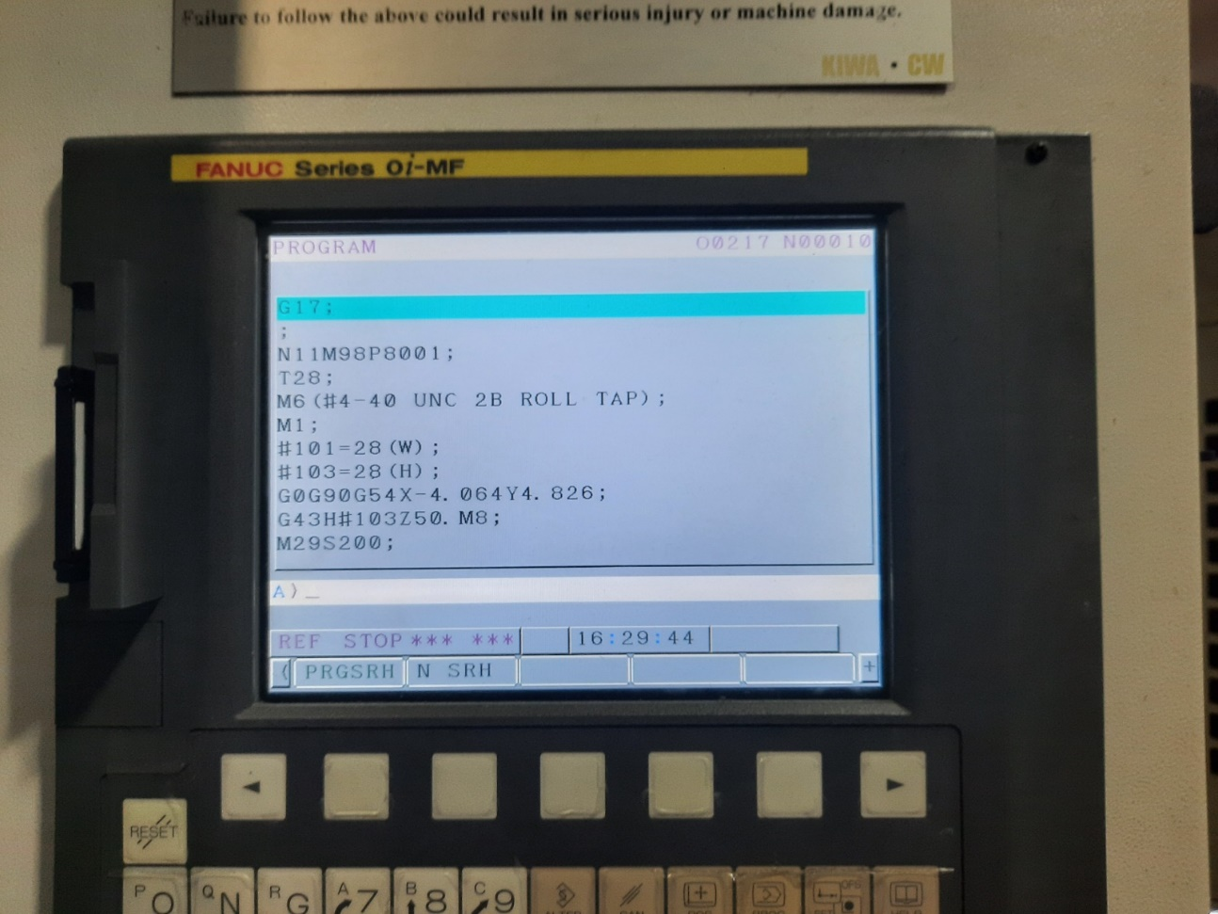

Step 3: Change the dimensions within the file to suit the target area
Now that the target area has been identified, change the dimensions within the OCR file to crop that specific area of text. Below are the variables that indicate the dimensions of the cropped area.
The result of the cropped image can be seen after the file has been ran.

Step 4: Run the Python file with Python3 with the image as the argument
Execute the Python file with the command

sudo Python3 OCR.py –image (image path)

Step 5: Analyse the result
The result of the OCR will be printed to the terminal.

Step 6: Adjusting the confidence filter
The OCR process has a “confidence” integer assigned to found strings. This indicates how sure the program is for that specific string to be present. This value can be changed to filter out unwanted trash text that is detected.

Change the integer found at this section of the code.

Section 4: References
Pytesserect Reference: https://pypi.org/project/pytesseract/
Code Credit: https://www.pyimagesearch.com/2020/05/25/tesseract-ocr-text-localization-and-detection/

